Title in Arial (14 pt Bold) Using First Capital Letters |  | Will be filled by  EMEC26

First Author¹, Second Author², Third Author^{1,2}
(1) Institution, Full institutional address, email address of first author (presenting author)
(2) Institution, Full institutional address

Keywords: Keyword1, Keyword2, Keyword3 (up to 5 keywords in Alphabetical order)

The Full Name of the presenting author should appear as the First Author. The total length of the abstract CANNOT EXCEED ONE PAGE. We recommend typing the abstract over this template to ensure that all abstract contributions have the same style in the final publication, i.e. text written in Arial 9 pt (justified) with page margins of 2.0 cm.
Abstracts can only be submitted through the online registration form and should be submitted as a docx file. The file should be named as “Surname_EMEC26_TYPE OF PRESENTATION.docx”, corresponding to the presenting author, the conference acronym (EMEC26), and the type of presentation (Oral, Flash or Poster). Examples are: Smith_EMEC26_POSTER.docx or Smith_EMEC26_ORAL.docx. Each presenting author can submit up to two abstracts.
When submitting your abstract, please, choose the most relevant topic. The organizing committee reserves the right to decide on a final topic assignment upon abstract evaluation.
If the authors wish to include a Figure, they should leave one line before and after it. The corresponding captions (Arial 8 pt) should straight follow the Figures, without any line between the Figure and its caption. Figures should be legible when printed in Black & White.

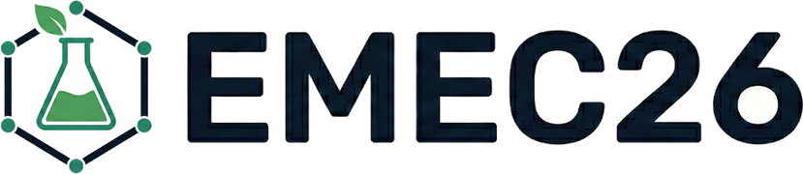

Figure 1. Caption (Arial 8 pt).

If the authors wish to include a Table then one line should be left before and after the Table.

Table 1. Caption (Arial 8 pt).
Arial ª | Bold ª | 8 pt
Arial | 8 pt | Arial | 8 pt
ª Footnote text if needed (8 pt).

The sections for acknowledgements and references, if any, should appear at the end (Arial 9 pt). Leave one line before the section titles. References should be sequentially numbered in the text and indicated in square brackets (e.g., “… [1,2]”). Please follow the corresponding styles for articles in journals [1], books [2] and chapters in edited books [3].

Acknowledgements
Thank you for reading these instructions. For more information, please feel free to contact us by email at info@emec26.eu

References
[1] Anson, C. M., & Cole, K. (2026). Empirical studies of writing and generative AI: Introduction to the special issue. Journal of Writing Research, 17(3). https://doi.org/10.17239/jowr-2026.17.03.01
[2] Wallwork, A. (2023). English for writing research papers (3rd ed.). Springer.
[3] Pubrica. (2026). How to write a research paper for journal publication in 2026. https://pubrica.com/academy/publication-support/how-to-write-research-paper-for-journal-publication-2026/

